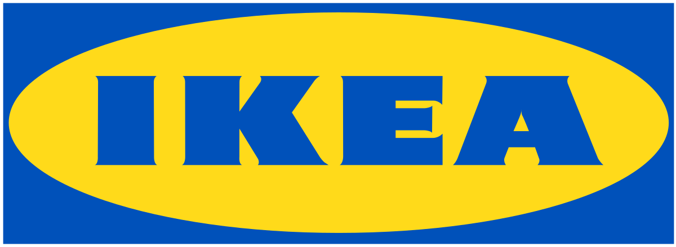

IKEA COMPANY
Name of student
Name of tutor
The institution of affiliation
Date

Assignment Task 1
Introduction
IKEA is a company founded in Sweden, in 1943, by Ingvar Kamprad and it mainly deals with home furnishings. Ingvar began by merely peddling useful home items to his neighbors on a bicycle. The company believes that home is an important place and children are the most important people. Since the founding of IKEA, the company's vision has championed for creating a better life for people across the globe by offering a wide range of home furnishings at low prices that can be afforded by all people. The mission and vision statement state that "at IKEA our vision is to create a better everyday life for the many people. Our business idea supports this vision by offering a wide range of well-designed, functional home furnishing products at prices so low that as many people as possible will be able to afford them."
The company is recognized across the globe for its modern designs for different types of appliances and furniture. Also, the company's interior design work is known for its eco-friendly simplicity. Moreover, the company is well recognized for its ability to embrace cost control, attention on operations, and the continuous development of its products. IKEA is also known for its corporate attributes that allowed the company to lower prices on its products and services by at least two percent over the year 2010 during a period of global expansion.
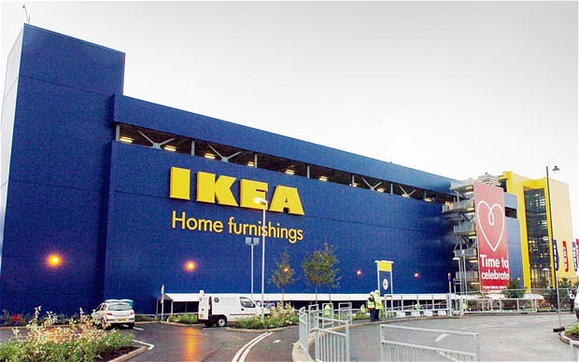
Products and Services
IKEA offers a wide range of furniture. Much of the company's furniture is designed to be assembled by their customers. Kamprad claims that this helps reduce the cost of packaging. This is also more convenient for those customers using public transport. The furniture is made of Medium-Density Fireboard (MDF) hence meeting material expectations in this 21st century. IKEA, therefore, use4s MDF in producing high quality products needed by its customers. Recently, IKEA has moved into the smart home business with IKEA TRADFRI smart lighting kit signaling the venture into this business. They have also formed a partnership with Phillips Hue. It has ventured into the wireless charging furniture hence seeks to change the home furniture business. IKEA has expanded its products base to include flat-pack houses and apartments, in a move to reduce the prices involved in a person buying a home for the first time. The joint venture with other companies like Skanska in Sweden ensures diversity in the housing industry. Also, the company ventures in solar PV systems sold in some of its stores across the globe. The company also sells solar systems online in the United Kingdom. IKEA also owns and operates the MEGA Family Shopping Centre chain in Russia. The company also launched the IKEA Family Mobile which runs on T-Mobile in the United Kingdom. Also, the company partnered with TCL to provide entertainment system products.
Corporate Structure
IKEA company is owned and operated by different not-for-profit and for-profit corporations. The company's organizational structure is mainly divided into two main parts which are operation and franchising. Operation covers mostly the management of majority stores, design, purchasing, supply functions and the manufacturing of furniture, which is managed by a private profit Dutch company known as INGKA Holding. The IKEA Foundation aims at improving opportunities for children and the youth in the world's poorest countries by providing donations to enhance holistic and long-term programs geared towards long term changes. Founded in 1982, this foundation has become active in addressing issues regarding child labor and has also partnered with different major corporations in the world to promote children's rights in the society. Today, the foundation has expanded its charter and works with reliable partners to enhance innovation in four key areas touching a child's life: a place to call home; a good beginning of life; quality education; and a sustainable family income (Ljungblom, 2014). INGKA foundation is chaired by Kamprad and other five executive committees which included her wife. The IKEA trademark is operated by a separate Dutch firm, Inter IKEA systems which are based in Luxembourg. Two companies in Australia run IKEA. INGKA Holding operates stores that are located on the East Coast. Cebas Pty Limited owns stores elsewhere in Australia including the Southern and Western Australia. All IKEA stores in every country pay 3% of sales of Inter Ikea as a franchise fee. The company's consumers are distributed mainly in Europe, America, Middle East, and Asia. Along with helping the company realizes a more non-taxable profit, IKEA's corporate structure allows Kamprad to keep an eye on the operations of INGKA Holding and hence the tight control of IKEA stores.
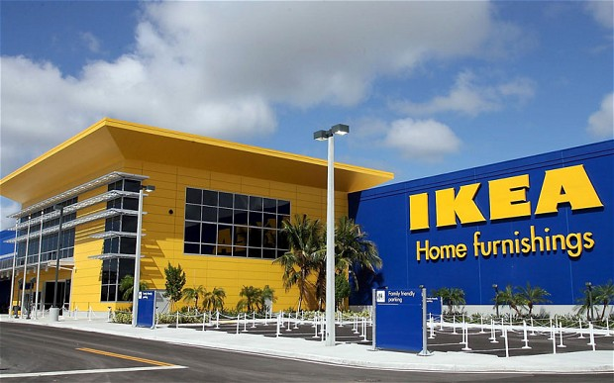
IKEA Corporate Strategies
Globalization is one aspect of trending currently for most companies across the globe. IKEA corporate strategies are geared towards determining its sustainability and gaining a competitive advantage among its competitors to achieve a higher share in the ever-changing competitive market especially new entry countries like Asia. For example, the company's globalization strategy in China comprises of a joint venture, localization, and pricing strategies. IKEA joint venture with some local Chinese companies aims at achieving the principle of equality and mutual benefits in different sectors of the economy. The joint venture strategy by IKEA is due to the political policy of the Chinese government. IKEA also embraces the localization strategy to suit the local culture in China. For example, the company provides a balcony section in housing because many people in China stay in apartments. The pricing strategy allows the company to remain competitive among other companies. For example, the company cut costs for some of its products such as single-cat Ektorp armchair which is cheaply sold in the United States as compared to prices offered by its rivals. IKEA corporate level strategies have allowed the company to attain impressive growth over the years.
IKEA Operation Strategy
IKEA's mission and vision are to ensure the availability of a wide range of home furnishing products and designs at prices so low that the majority of people in the society can afford to buy them. Kamprad's innovative strategy was to design furniture that was inexpensive to customers, readily available at stores and displayed in showrooms with detailed information and tickets making it unnecessary for the requirement of salespersons. IKEA customers often spend more time in stores as compared to the time they spend in stores of other rival retailers. The company distinguishes itself from its competitors with how it organizes its stores. Shopping in IKEA stores is an experience. The company's stores double as warehouses. All their furniture are laid out and showcased under one roof as it would be in a home setting. In this manner, IKEA shoppers get to choose their products on a broad scale. Employees are available for questions in the stores, but customers would often select, order, pick up and transport their selections.
IKEA is embracing a different operation strategy from their business rivals. The company's operation has to often cope with large volumes since their products are highly specialized. The variety of products the company's operation needs to create is low to medium since they offer standardized and well-defined products. The variation to be embraced in operation is low because sales of furniture are often steady over the year and are usually predictable. The degree of customer contact is often low. Hence the company's operation strategy is focused on low cost. Furthermore, the company is targeting two different groups of customers. The company first targets young adults from low to middle-class income family who may have or may have no children. The company also targets business customers who may be running small to medium size of offices. Since their target group is often low to middle-class income earners, IKEA is more price conscious, and they demand different information, support, and other vital services. IKEA's operation strategy is compatible with other strategies by linking it with their performance objectives. Their performance objectives are defined by quality, speed, dependability, flexibility, and cost, which may impact on the effectiveness of other vital strategies. Four main vital aspects make IKEA unique from other competitors: volume of their outputs; the variety of the outputs; the variation in demand for their outputs; and the degree of customer contact that IKEA has. These four components as described below illustrate what has made IKEA the furniture retailer with a difference.
The Volume Dimension
Since IKEA operates like a warehouse, it manufactures a high volume of furniture and other products that could be readily self-assembled. The company is also found in other countries hence can allow economies of scale by bringing costs down with the high-volume production realized in the company. However, economist's view that despite IKEA being a high-volume production business, it has a lean buffering capacity hence a limited amount of stock is bought. This ensures there is no possibility of unwanted stock in its production.
The Variety Dimension
IKEA's furniture is often the value for money with a comprehensive option of furniture choices offered. The furniture is designed to be stored and sold in a warehouse kind of setting and is capable of easy assembly by their customers. The design from the Swedish point of view emphasizes bold colors and styles. IKEA promotes its products to be modular hence allowing different variations of the same essential product to be customized to produce greater variety. This strategy allows the company to provide a greater variety of its products without retaining large amounts of stock. Customers also have the change to walk around and pick any products they want without waiting for sales personnel to serve them. They are flexible to browse through the stores and pick whatever they need. The variety dimension allows customers to save on time while picking their products. The philosophy in the company is to let customers make their decisions regarding shopping at their own time. The staff only needs to help customers find their way around the showroom.
The Variation in Demand
The demand pattern is variable. Though not so many significant factors may influence the demand for IKEA's furniture, there exist specific factors that will vary the demand for these products. Because IKEA stores are located away from many urban centers, it can prove challenging for customers who don't drive to access the stores. Few customers may access the stores especially during the rainy season hence may not feel it necessary to drive away from town to get the furniture. For this same reason, customers may prioritize doing their shopping on weekends. Therefore, it means the weekends will be full of activities unlike during the weekdays. One problem associated with this is that customers who need to do their shopping at IKEA will be turned off by the large crowds of people shopping during the weekend.
The Visibility Dimension
This refers to the operation contact the operation has. Even though IKEA has adopted the self-service concept among customers, the company maintains a high level of contact with the customers. To make shopping easy, the company provides catalogs, tape measures, shopping lists, and writing materials to write notes and measurements. Free catalogs are provided to customers to help them see the available range of products available in the stores. Moreover, the IKEA stores are designed to have a family shopping experience that offers customer care services and other essential facilities like restaurant, daycare facilities and also a Swedish shop. Stores also provide car roof racks which are available for purchase at cost. The desire to integrate these values into their business is what makes IKEA different from other traditional furniture retailers. The company's success can be attributed to its vast experience in the retail market, product differentiation, and cost leadership. IKEA is perhaps one of the most successful retail industries operating on a global scale based on the unique operation strategies described above.
Operational Challenges
IKEA's vision is to provide their products at a reasonable price. However, profit maximization is reduced when they provide products at a lower price than expected. This is a possible threat to profit and for the overall growth of the company. Thus IKEA compromised on this to achieve its vision of providing a full range of well-designed housing products at prices affordable to as many people as possible. However, IKEA's low-cost operation strategy may backfire in a market where consumers view expensive goods as of higher quality. If buyers see IKEA's goods as cheaper as compared products from other retailers, the goods may be seen to be of inferior quality. So the company is compromising on not serving the buyers interested in premium quality furniture. The company is also striving to maintain its quality hence it has sometimes been unable to meet international standards. Lowering costs has also led to customer care not getting proper attention, and the workers do not have the time or resources for proper international training (Levine, 2010).
Quality management has also been heavily impacted in the company. The company uses crucial advertising campaigns that have affected the marketing of their products. IKEA is unable to research thoroughly on their potential market because of being cost conscious, and they have therefore missed on potential customers in the market. The company also needs to maintain its international brand in host countries. They need to pay close attention to the customs and traditions of host nations and experts view they have failed to so for a long time. It has failed to do so hence profits falling in certain countries like the United States. To improve quality, the company can take different steps. IKEA can adopt Total Quality Management (TQM) in their operation to ensure quality. It needs to inject more money into its processes to realize more profits. IKEA also needs to develop customer focus and train employees to provide the best customer care services. Customer care focus is vital to both internal and external working environment of the organization. The company also needs to focus on leadership in their stores. Leadership in each store should have a similar set or rules, aims, and objectives. Leaders can be trained in stores together to realize more profits.
Supply Chain Management
IKEA's supply chain is well organized and gears towards satisfying the needs of all relevant partners involved with the company. Supply chain management is involved with the acquisition of materials, manufacturing and the delivery to all of their consumers. One of the main challenges in supply chain management is maintaining high quality products while sticking to a low pricing strategy. The raw materials used in the company are of high quality hence making the final products produced to be of high quality too. These materials are expensive. This is a challenge to the company since IKEA needs to attain a break-even despite such an occurrence. Because of this occurrence, the company has been forced to minimize other costs to cater for the cost of raw materials. One of the measures to prevent this occurrence is taking the manufacturing process to develop nations. In such countries, labor and other factors of production are cheap. Therefore, the company can attain a break-even. Another challenge facing the company supplies is issues regarding criticism from some agencies associated with environmental aspects. IKEA works on the grounds of ensuring the maintenance of the environment and social sustainability. Some bodies criticize their products as not being environmentally friendly. For example, formaldehyde scandal revealed the impact the acid had on human health. Due to such scandals, IKEA had to reduce formaldehyde levels in its products (Collins, 2010). They also employed scientists that would shape the future of products produced by the company. All these strategies resulted in increased costs in IKEA's supply chain.
The company is also being faced with the threat of receiving low-quality products form some of their suppliers of raw materials. The company deals with more than fifty suppliers of raw materials. The suppliers have varying objectives and goals to realize. This implies that their motives may influence their actions. For this reason, cases of supplying low-quality products may arise. Once such a scenario has been experienced, the company is supposed to return the materials to such suppliers. This delays the process of production hence affecting other operations (Edvardsson and Enquist, 2009). Today, the company is dealing with already established suppliers with a good history with the company over the years.
Lean Management and Quality Management Approaches
Lean management is a way of running a company that embraces the aspect of continuous improvement and hence the overall achievement of efficiency and quality. Lean management is geared towards eliminating waste of time, effort or money in the effort towards realizing success in business. One way of increasing efficiency and cutting costs at IKEA is through the way they sell furniture parts separately. This allows customers to choose what they exactly need. In this manner, the company does not need to use resources to package and store all their different combinations and also customers can customize their selections. Their warehouses is also an example of how the company reduces cost by letting consumers take care of their legwork. The well-organized aisles make it faster for employees to stock the shelves, faster for customers to navigate the showroom, and hence saving on time. Quality management approach defines business processes focused on improving and meeting the requirements of customers and hence satisfying their needs (Turban, 2010). TQM is a process of managing an entire organization towards ensuring success in every department geared towards satisfying the customer demands. IKE is well organized to ensure the overall success of the company.
Artificial Intelligence in Business
Artificial intelligence is the latest trend embraced in the many aspects of the economy today. Artificial intelligence brings the most significant benefits to finance. In this era, financial experts use this innovation to keep track of prices and indices hence providing the best financial decisions. Artificial intelligence makes trading easy and also less risky. Artificial intelligence also may prevent fraud activities in the business sector. For example, the use of machine learning algorithms provides financial security in business. Kount is one of the best platforms to help to prevent fraud in business hence increasing their sales. Digital marketing may also offer the best platform to market products (Larsen, 2007). The goal of such platforms is to ensure profit-generating means for a company. Some challenges may arise if a company like IKEA tries to implement artificial intelligence. One of the challenges is the loss of people power. Technology may impact the labor required in a company hence loss of some important jobs in the organization. Another challenge is in ensuring the right speed and quality of products on the platforms. An example is the 3D materials used. However, artificial intelligence needs to be embraced especially in this changing world of technology.
This report focuses on IKEA history, operational strategy, supply chain management, lean management and quality management approaches as well as artificial intelligence in business. All these aspects describe IKEA's business strategy in the ever-changing business world.
Assignment Task 2
ONLINE MOBILE TECHNOLOGY PROJECT
The Purpose of this plan
The Online Mobile Technology Project Plan will define the project plan, including the project's goals and objectives. Also, this plan will serve as bringing different parties including the sponsor of the project, the steering committee, the project manager, the project team, and the people associated with the project. The project plan highlights the following:
The project purpose
The goals and objectives of business and project
Scope and expectations
The roles and responsibilities
Assumptions and constraints
Project management approach
Ground rules for the project
Project budget
Project timeline
The conceptual design of new technology
Background Information
This section needs to describe the work you have been able to complete to date, the choices one had regarding the hardware/software, and an explanation of how one decided to use relevant technology in the app.
Project Approach
This section needs to outline how one intends to roll out the technology and includes the highest level milestones. For example:
Phase One: Secure an understanding with vendors
Phase Two: Install the equipment
Phase Three: Install/Test the software
Phase Four: Conduct Hardware/Software Testing
Phase Five: Carry out training
The Business Goals and Objectives
The goals and objectives of this business project will focus on embracing a mobile technology that:
Improves customer satisfaction and safety
Facilitates quick sharing of information both internally and externally of the organization
Enhances the ability for the staff to perform their work effectively
Facilitates the reduction in levels of fraud hence boasting shopping security
Provides data security
Provides a reliable technology base for the future
Facilitates electronic capture of data
That is easy to use by all people
Project Goals and Objectives
Sample project goals and objectives:
Ensure that the users of the application have an input into this design process
Accomplish the goals and objectives of the business within the defined budget and set time
Create an agreement with the target market and Departments in the company
SCOPE
The project will introduce new mobile technology to enhance the shopping experience for IKEA customers. It includes the following:
A 3D view platform
Visual search
Wireless charging
Smart lighting
The initials attempts at risk assessment aimed at identifying, characterizing, prioritizing and documentation of a mitigation approach relative to such risks that can be realized before the start of this project. The risk assessment of this project will continuously be monitored throughout this project and will be well documented by the project manager. Time needs to be allocated to each steering committee meeting to be able to identify new risks and discuss the mitigation strategies. The manager will be tasked with conveying amendments and the recommended requirements to the steering committee on a monthly basis as also conditions may warrant.
Project Assumptions
The below assumptions were made in preparing the project plan:
IKEA customers are willing to embrace the business operations to take advantage of revolutions brought about by the new mobile technology
The company's management will ensure the availability of project team members to complete project tasks and objectives
The steering committee will play a key role in ensuring the project is executed
Team members in the project will embrace the communication plan
The advancing technological world will provide the infrastructure that can be able to support the innovation
The project plan is subject to change as new information and emerging issues are revealed
Project Constraints
The below represent known project constraints:
There are limited funding sources for the project
A limited number of smartphone knowledge users in some parts of the world
Possible removal of project funders
In the event of any of the above happening, the project would become challenging to implement.
Project Roles and Responsibilities
Project sponsor
The sponsor is the ultimate decision-maker and the tie-breaker
Provides project oversight and guidance
Reviews and approves some of the project elements
The Steering Committee
The committee commits the department's resources
It approves significant funding and resource allocation strategies
It helps in resolving conflicts and issues
Reviews project deliverables
Project Manager
Manages the whole project according to the project plan
Supervises all consultants
Provides the needed guidance and direction of the project
Handles problem resolution
Project Participants
Understanding the user needs and business operations in their areas
Act as consumer advocates in their areas
Creates work products
Help identify and to remove barriers experienced in the project
Issue Management
It is important to note that information may change in the project plan as the project progresses. Any of these changes may impact one of these three crucial success factors: the available time, the available resources, or the project quality. Coordination needs to be done in the following steps
Step 1: The project manager needs to document change that impacts the project scope, schedule, or staffing
Step 2: The manager will review the change and forward to the steering committee for review and decision
Step 3: A consensus decision is reached upon by the committee and gives a decision
Step 4: Reviewing the decision matrix and hence rendering the final decision
Communication Plan
Providing information about the project is essential to the success of the overall project. The participants need to be aware of the status of the project and how they may be affected as the project progresses. The more people are educated and talked to about the project, the more likely they may be able to participate in the project. The communication methodology may utilize the following directions to promote effective communication.
Top-down: It is important for all participants in the project to embrace a unified communication platform. The executives of the organization will be able to listen to all levels of the organization.
Bottom-up: Solutions need to be communicated to ensure the confidence of personnel involved in realizing the changes in the project. All participants need to embrace good communication skills to realize the success of the project.
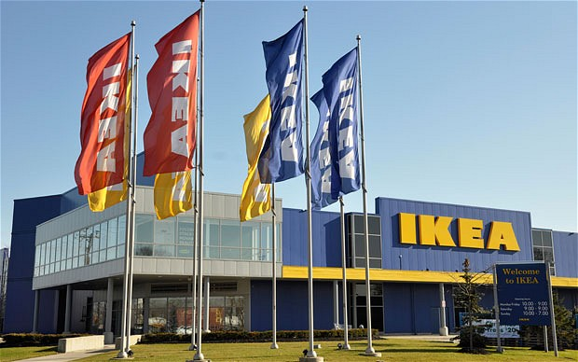

Reference
Collins, J. D., Worthington, W. J., Reyes, P. M., & Romero, M. (2010). Knowledge management, supply chain technologies, and firm performance. Management Research Review, 33(10), 947-960.
Edvardsson, B., & Enquist, B., 2009. Values-based service for sustainable business: lessons from IKEA. London: Routledge.
Larsen, T., 2007. Managing the global supply chain (3rd Ed.). Copenhagen: Copenhagen Business School;
Ljungblom, M. (2014). Ethics and Lean Management–a paradox?. International Journal of Quality and Service Sciences, 6(2/3), 191-202.
Tarnovskaya, V., Elg, U., & Burt, S. (2008). The role of corporate branding in a market driving strategy. International Journal of Retail & Distribution Management, 36(11), 941-965.
Turban, E., Sharda, R., & Delen, D. (2010). Decision Support and Business Intelligence Systems (required). Google Scholar.

